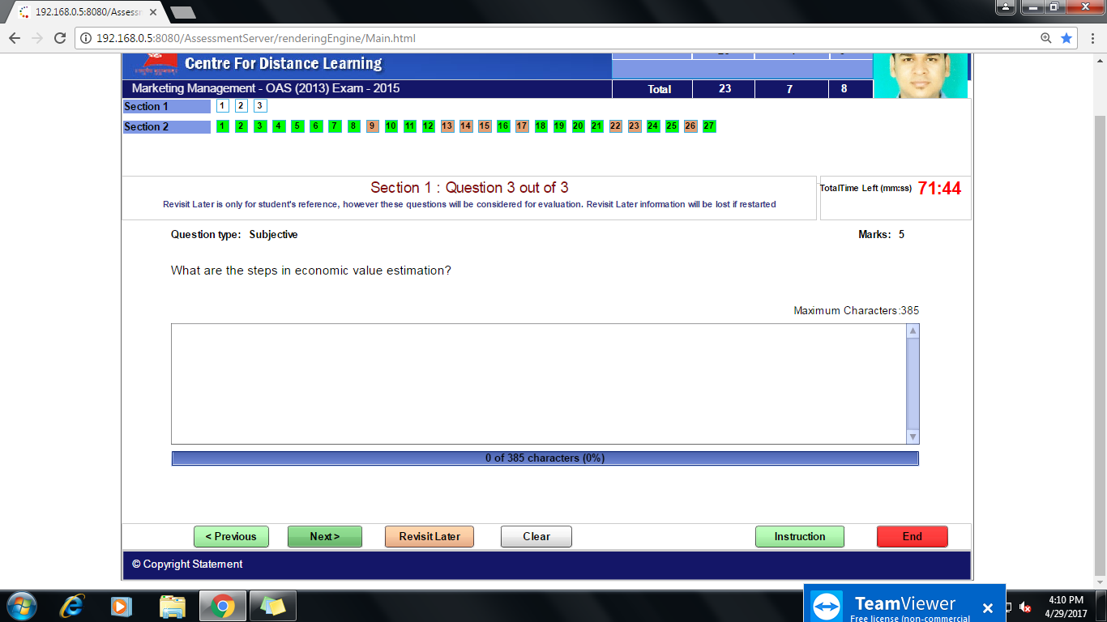
Step 1 : segment your market - and define the next best alternatives
Step 2 : define the benefit ladder (features - advantages - benefits)
Step 3: select your resonating value drivers - both compelling and simple value arguments, points of difference between your solution and your competitor's, that deliver the greatest value to the target customers.
Step 4 : build your data sheet (variables to calculate the value)
Step 5 : build your economic value calculator
Step 6 : build your value sentences and value communication toolbox
